**Advance Excel Assignment 4**

1. **To use the ribbon commands, what menu and grouping of commands will you find the Insert and Delete command?**
2. **File**- allows you to jump into the backstage view that contains the essential file-related commands and Excel options. This tab was introduced in Excel 2010 as the replacement for the Office button in Excel 2007 and the File menu in earlier versions.
3. **Home**- contains the most frequently used commands such as copying and pasting, sorting and filtering, formatting, etc.
4. **Insert** – is used for adding different objects in a worksheet such as images, charts, PivotTables, hyperlinks, special symbols, equations, headers and footers.
5. **Draw** - depending on the device type you're using, it lets you draw with a digital pen, mouse, or finger. This tab is available in Excel 2013 and later, but like the [Developer tab](https://www.ablebits.com/office-addins-blog/add-developer-tab-excel/) it is not visible by default.
6. **Page Layout**- provides tools to manage the worksheet appearance, both onscreen and printed. These tools control theme settings, gridlines, page margins, object aligning, and print area.
7. **Formulas**- contains tools for inserting functions, defining names and controlling the calculation options.
8. **Data**- holds the commands for managing the worksheet data as well as connecting to external data.
9. **Review**- allows you to check spelling, track changes, add comments and notes, protect worksheets and workbooks.
10. **View**- provides commands for switching between worksheet views, freezing panes, viewing and arranging multiple windows.

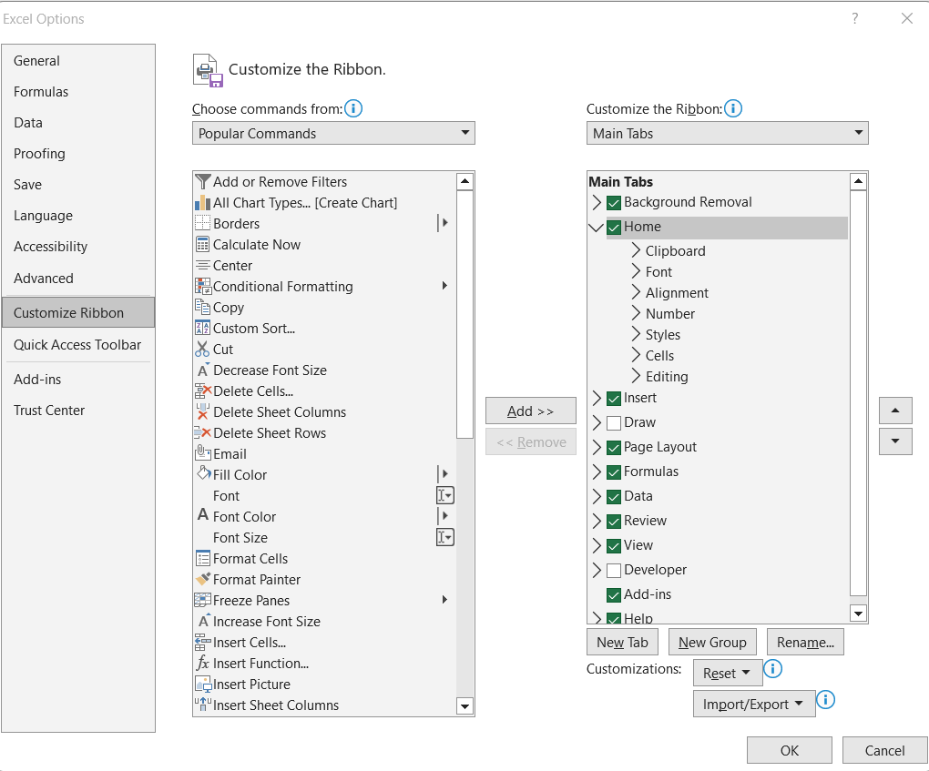

**2. If you set a row height or column width to 0 (zero), what happens to the row and column?**

It will delete that particular row or column.

**3. Is there a need to change the height and width in a cell? Why?**

It is necessary to change width and height in excel to fit the data.

Excel by default provide equal width and height with respect to columns and rows. Whenever we enter a lengthy data, few characters will get displayed and other will be present inside the cell but will be hidden to the user. It is necessary to change the rows and columns height and width to have a good presentation in excel.

**4. What is the keyboard shortcut to unhide rows?**

To unhide all rows and columns, select the whole sheet as explained above, and then press **Ctrl + Shift + 9** to show hidden rows and Ctrl + Shift + 0 to show hidden columns.

**5. How to hide rows containing blank cells?**

1. Select the data range which contains the blank cells you want to hide.
2. Then click**Home** >**Find & Select** > **Go To Special**, see screenshot:
3. **Tip**: You also can press**Ctrl + G** to open**Go To** dialog and click **Special** to get the **Go To Special** dialog.
4. And in the **Go To Special** dialog, select **Blanks** option, and then click **OK** button.
5. All of the blank cells in the selection have been selected.
6. Then you can press **Ctrl + 9** keys together to hide the rows which have blank cells.

**6. What are the steps to hide the duplicate values using conditional formatting in excel?**

1. Select the range you want to hide duplicates. Here I select range A1:F11.
2. Then click **Conditional Formatting** > **Highlight Cells Rules** > **Duplicate Values** under **Home**tab. See screenshot:
3. In the **Duplicate Values** dialog box, select**Custom Format** in the v**alues with** drop-down list, and then click the **OK** button.
4. In the **Format Cells** dialog box, go to the **Font** tab, and in the **Color** drop-down list, choose a font color which matches the background color of your selected range cell. And finally click the **OK** button.
5. When it returns to the Duplicate Values dialog box, click the OK button.
6. Now all duplicate records in selected columns are hidden immediately.